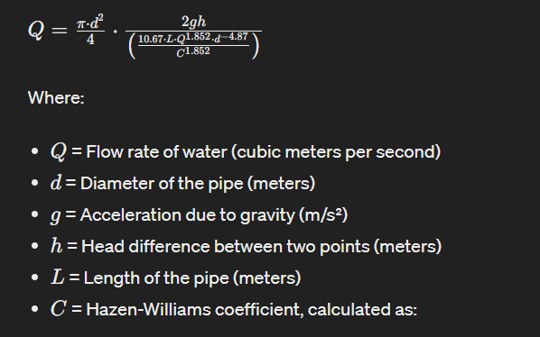

This is a combined formula including all parameters to calculate flow of water with which we can determine leakage and its amount

Since kinematic velocity and Hazen-William coefficient varies for every temperature so this value keeps changing

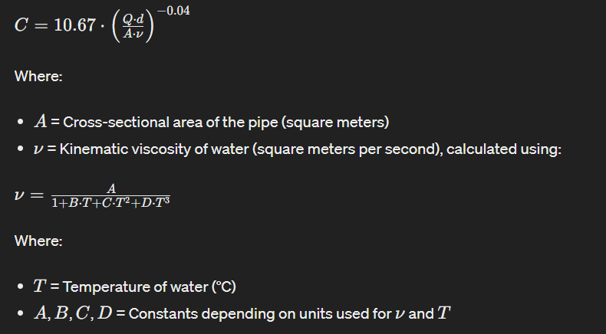

NOW

The point is how to calculate amount of leakage

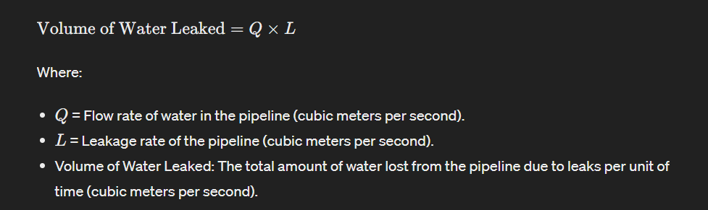

And the leakage rate is calculated as

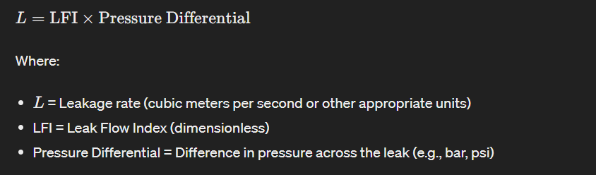

LFI changes for every quality shape and length of pipe